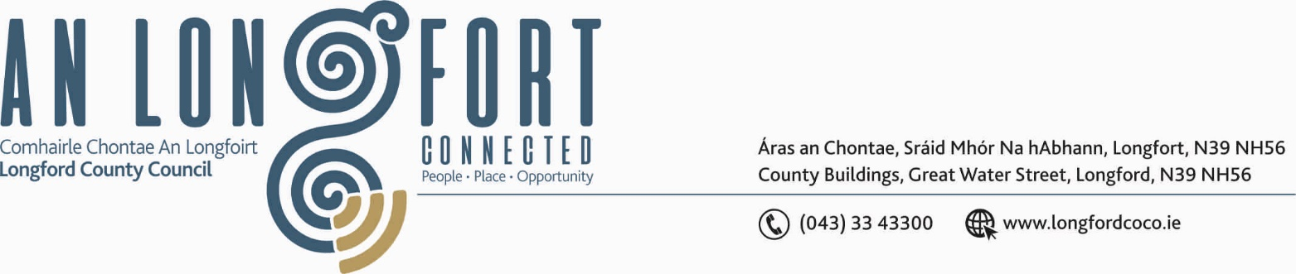

LONGFORD MUNICIPAL DISTRICT

19th September 2019.

To: Each Member of Longford Municipal District.

Dear Member,

You are requested to attend Meeting of Longford Municipal District to be held in the Council Chamber, Town Hall, Market Square, Longford, on Wednesday, 25th September 2019 at
4.30 p.m. to transact business, as set out on the Agenda hereunder.


Yours sincerely,

_______________
Anne Lee,
Meetings Administrator.

AGENDA

Prayer before meeting.

- Confirmation of Minutes of Longford Municipal District Meeting held on the
24th July 2019 – copy enclosed.

- Matters arising from Minutes.

- Declaration of Interest by Members.

- Management Report - to follow.

- Update on CCTV, including adopted Minutes of Longford Town Community CCTV
Steering Group Meeting held on the 11th April 2019.

- Broadband Connection Points.

- Review of Standing Orders - draft enclosed.

- Update on Town & Park Warden Position.

- Notices of Motions, submitted by Councillors, as listed hereunder -

Councillor Joe Flaherty.
“That we forward to the next meeting of the Place Names Committee a recommendation that they provide a name for the 'street' of mainly commercial premises that backs onto the Shopping Centre carpark from Chapel St. A number of the units recently changed hands with new ventures planned and as part of the planned rehabilitation of the car park area, it would be good if this 'street' finally gets a name.”
“Longford LEA scopes up to three possible sites in the environs of Longford town that would each be capable of facilitating 30-50 houses under a serviced site initiative. Detailed costings and proposals to be brought to Infrastructure SPC with a view to a planned programme for the three sites over the next three years, 2020-22.”

“Regeneration Team prioritises a solar energy generating initiative for the LIADH building that could include retaining the existing structure and generate sufficient power to fuel the building itself and much more.”
Councillor Martin Monaghan.
“That road safety issues be addressed on approach roads to the village of Newtownforbes especially around the environs of the National School.”

- Consideration of request from Longford Tidy Towns Committee to host annual Awards
Event.

- A.O.B.



